**Signal Analysis**

**Lab 2**

***Task #1: Time Scaling: Compression and Expansion***

%Time Scaling: Compression and expansion

t=-2*pi:0.001:2*pi;

a=input('Enter the value of a:')

subplot(2,1,1);

y=sin(2*pi*t);

plot(t,y);

grid on;

ylabel('Amplitude -->.');

xlabel('t -->.');

title('Original Signal');

subplot(2,1,2);

y=sin(2*pi*a*t);

plot(t,y);

grid on;

ylabel('Amplitude -->.');

xlabel('t -->.');

title('Time Scaled Signal');

**Sample Run 1 with a = 2: [Compression]**

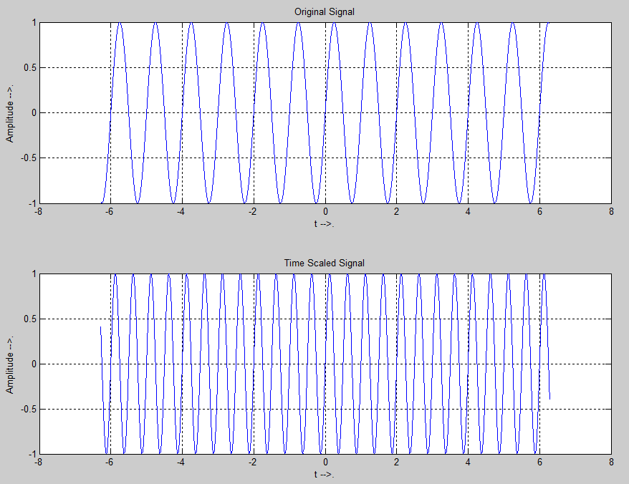

**Sample Run 2 with a = 0.5: [Expansion]**

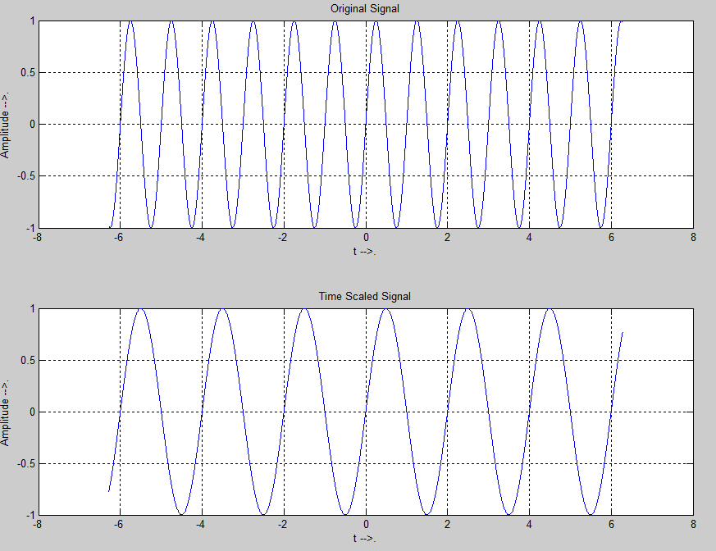

***Task #2: Time Reversal***

%Time Reversal

t=-2*pi:0.01:2*pi;

a=input('Enter the value of a');

subplot(2,1,1);

y=exp(a*t);

plot(t,y);

grid on;

ylabel('Amplitude -->.');

xlabel('t -->.');

title('Original Signal');

subplot(2,1,2);

y=exp(a*(-t));

plot(t,y);

grid on;

ylabel('Amplitude -->.');

xlabel('t -->.');

title('Time Reversed Signal');

Sample Run with a=2[Exponentially growing signal]

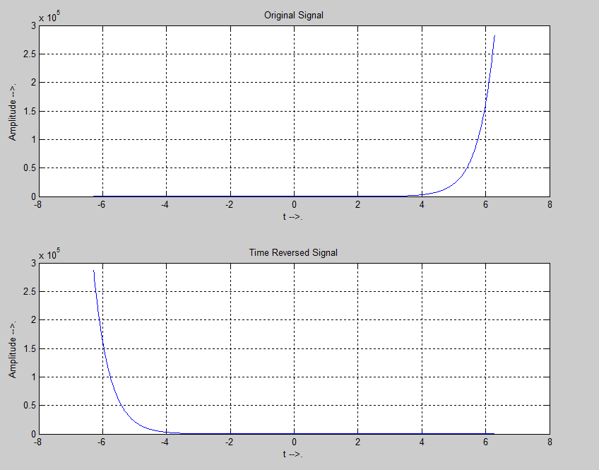

Task 3: Amplitude Scaling

%Amplitude Scaling

t=-2*pi:0.01:2*pi;

c=input('Enter the value of c');

subplot(2,1,1);

y=sin(2*pi*t);

plot(t,y);

grid on;

ylabel('Amplitude -->.');

xlabel('t -->.');

title('Original Signal');

subplot(2,1,2);

y=c*sin(2*pi*t);

plot(t,y);

grid on;

ylabel('Amplitude -->.');

xlabel('t -->.');

title('Amplitude Scaled Signal');

Sample Run with c=2

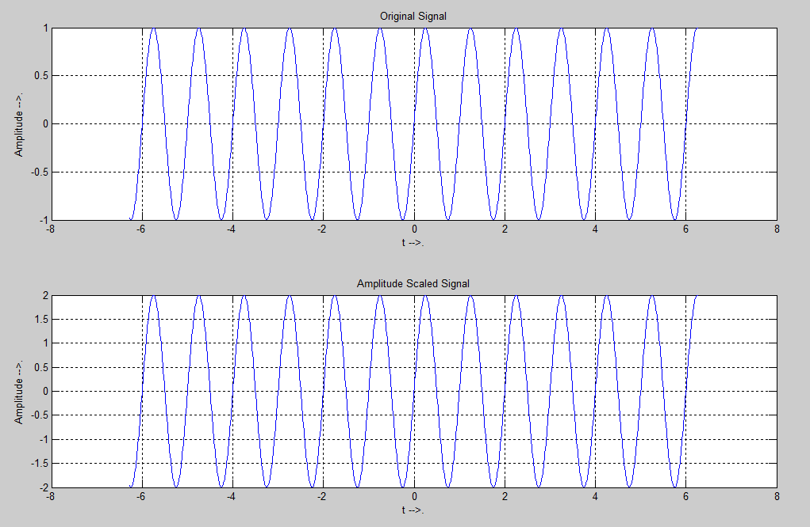

Task 4: Time Differentiation:

syms t;

x = t*exp(-3*t)+0.25*exp(-3*t);

%x=t.^3;

%x=sin(t);

xd = diff(x,t,1)

xdd = diff(x,t,2)

t_ = 0:0.01:3;

x_ = subs(x,t,t_);

xd_ = subs(xd,t,t_);

xdd_ = subs(xdd,t,t_);

plot(t_,x_,'b',t_,xd_,'g',t_,xdd_,'r')

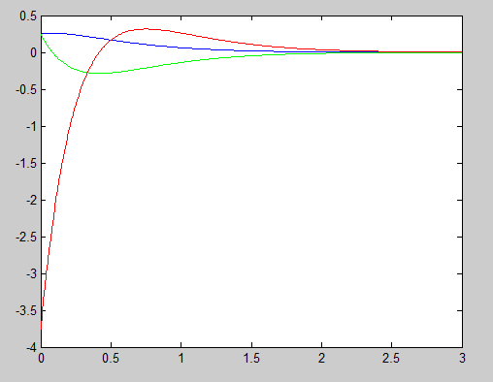

Task 5: Time Integration:

t = linspace(-7, 7);

func=@(x) x.^2;

y = arrayfun(@(m) integral(func, 0, m), t);

plot(t, y);

